Junit Test Proof  
  
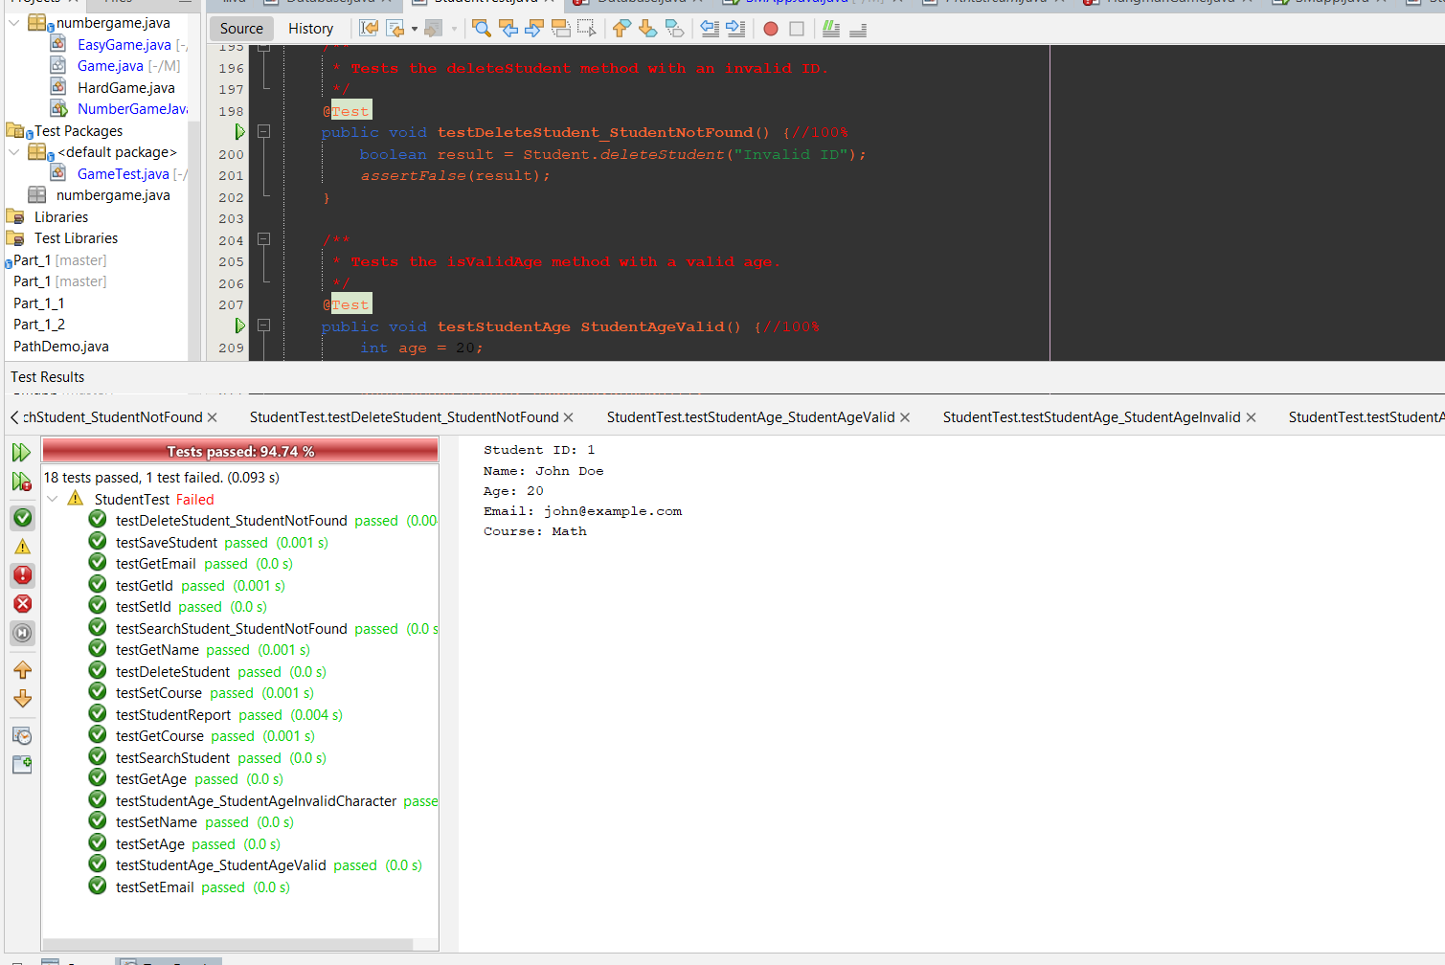

Figure 1 SMApp Unit tests  
  
  
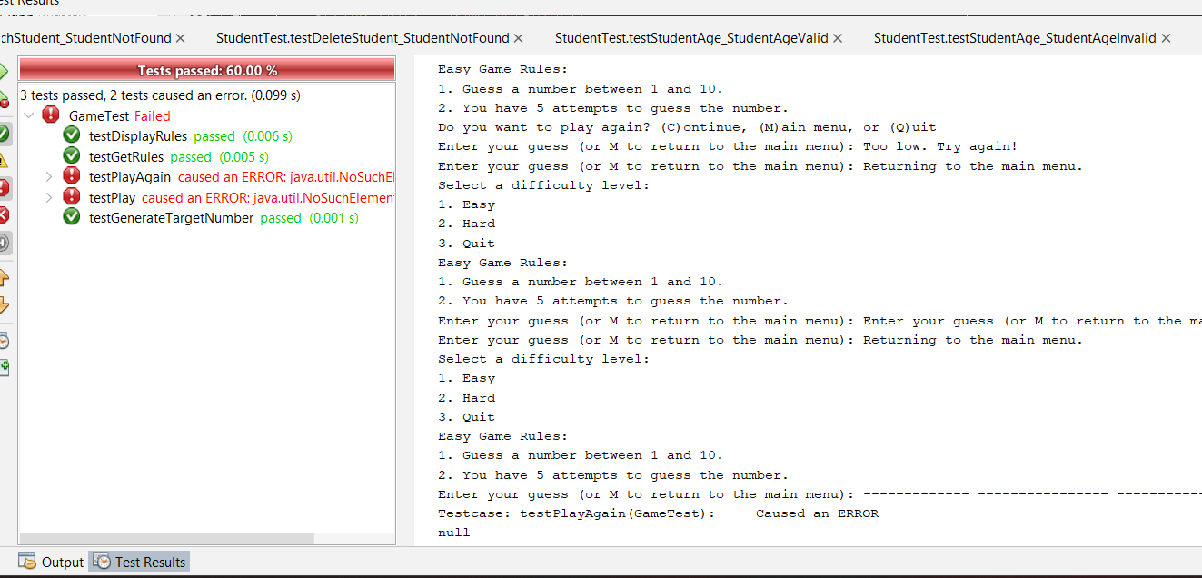

Figure 2NumberGame Unit Test